Short Communications

Pakistan J. Zool., vol. 43(3), pp. 593-596, 2011.

Contribution on the Status and Distribution of Shrike Species in South-Eastern Anatolia, Turkey

Recep Karakaş*
Department of Biology, Science and Art Faculty, University of Dicle, 21280 Diyarbakir, Turkey.

Abstract.- The status and distribution of four shrike species (Lanius collurio, L. minor, L. senator and L. nubicus) belonging to Laniidae family in South-eastern Anatolia is presented on the basis of personal observations and available records. L. minor is a passage migrant while the others are summer visitors and regularly breed in the region. Expanding agricultural production system under the South-east Anatolia Project (GAP) is the main threat to the shrike and other bird species populations in the region. The use of fertilizer, herbicides and pesticides used to boost agricultural production also impact the birds population adversely.

Key words: Laniidae, shrike species, south-eastern Anatolia, Turkey.

Shrikes are passerine birds of the family Laniidae and many of them are widely distributed in Eurasia and Africa (Cramp, 1998). They inhabit open habitats, especially steppe and savannah. Seven shrike species have been reported from Turkey; four of them are (L. collurio, L. minor, L. senator and L. nubicus) regular visitors, two vagrant (L. isabellinus and L. schach) and the seventh is sporadic winter visitor (L. excubitor) (Kasparek and Bilgin, 1996; Kirwan et al., 2008). The four regular visitors (L. collurio, L. minor, L. senator, and L. nubicus) are subject to habitat loss in their European habitats and classified as declining (Birdlife, 2004).

Land use is being modified in south-eastern Turkey as a result of implementation of South-east Anatolia Project (GAP - Güneydoğu Anadolu Projesi) and effecting the agricultural regime changes. Climatic change is also impacting the habitat conditions (Ünlü et al., 1997; Welch, 2004).
_________________________
* Corresponding author: rkarakas@dicle.edu.tr
0030-9923/2011/0003-0593 $ 8.00/0
Copyright 2011 Zoological Society of Pakistan.
Through this project, many parts of the steppe areas have been converted to arable land by irrigation, mainly after 1990s. Intensification of agriculture together with effects of fertilizer, herbicides and pesticides, used to increase crop production has affected the food availability for to many bird species including shrike populations in the region.
This paper describes the current breeding distribution of the four shrike species in South-eastern part of Turkey, based on personal observations and recent literature.

Materials and methods
In order to determine the distribution of shrike species in South-eastern Anatolia region, all records of shrikes between the years 1998-2004 were obtained from the published as well as unpublished works on the distribution of birds in the region. Personal observations were recorded using line transect method during field excursions conducted in areas shown as circles on the map (Fig.1).

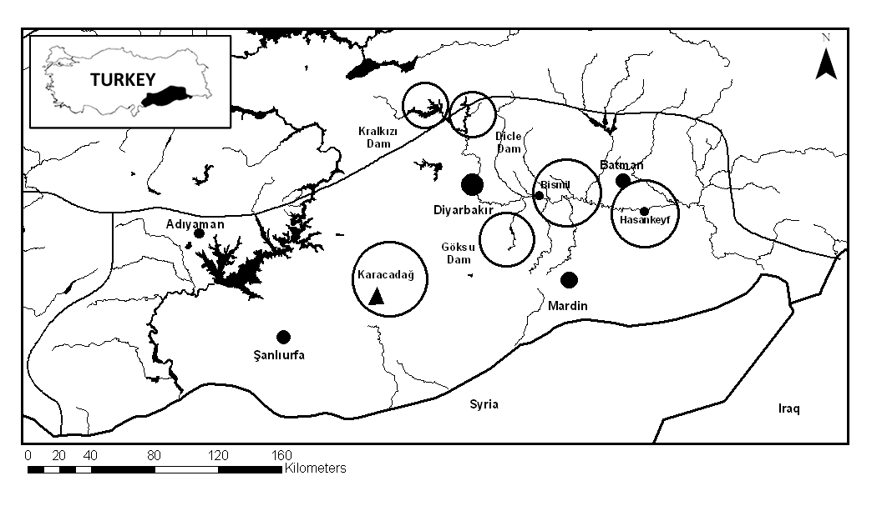

Fig. 1. The main studied areas

Results and Discussion
Table I shows the distribution of four shrike species in the region between the years 1998-2004.

Red-backed shrike Lanius collurio
The red-backed shrike (L. collurio) has a wide breeding distribution covering most of central and eastern Europe to western and central Asia, including Turkey, Cyprus, and northern and western Iran (Cramp, 1998). In Europe, this species is in SPEC 3 category and has been provisionally evaluated as ‘’Depleted’’ (Birdlife, 2004), due to the loss and fragmentation of habitat and overuse of pesticides (Cramp, 1998). It breeds in open cultivated areas, warm, dry or even semi-arid habitats with shrubs, or low trees. The species was reported as widespread in many parts of Turkey (Cramp, 1998). The population was estimated at 400,000 – 800,000 pairs (2001 data, Birdlife, 2004) even though breeding population of this species is declining in Turkey.
The species visits the region during the summer breeding season (confirmed breeding) and could be seen in many parts of South-eastern Anatolia between middle of April and beginning of September (there is one record on 11 Oct 2003, presumably late migrant). During field excursions it was observed that the females arrived in the region later than males. These observations are in consonance with Biricik (1996), Kasparek and Bilgin (1996) and Kirwan et al. (2008).

Lesser grey shrike Lanius minor
The lesser grey shrike (L. minor) is distributed from north-eastern Spain, south-eastern Europe to central Asia. It mainly prefers dry open lowland habitats with trees and bushes (Cramp, 1998). Although its European breeding population is large, there were widespread declines across most of Europe (Lefranc, 1995) and Turkey (Birdlife, 2004). Breeding population of this species in Turkey is estimated to be as 50,000-200,000 pairs (2001 data, Birdlife, 2004). The species is in SPEC 2 category* and provisionally evaluated as declining in Europe (Birdlife, 2004), probably due to reduction in prey population or food due to pesticide use (Cramp, 1998).
The species was recorded between the end of April to end of May, and from the middle of August to September, could be seen in many parts of South-eastern Anatolia i.e. during spring and autumn migration together with L. collurio in the same habitats. Although Martins (1989) mentioned the species as local and uncommon summer visitor for South-eastern Anatolia together with large numbers on passage through Turkey, my observations suggest that the species is only a passage migrant.

Woodchat shrike Lanius senator
The woodchat shrike (L. senator) is a widespread summer visitor to much of southern and central Europe, including Iberia, north-west Africa, the Middle East, Turkey and east of Iran (Cramp, 1998). The species continued to decline across most of its European range, so it is provisionally evaluated as ‘’declining’’ and SPEC 2 category (Birdlife, 2004). The breeding population of species was estimated at 30,000 – 90,000 pairs and declining (2001 data, Birdlife, 2004). It mainly uses open cultivated areas, semi-open areas with bushes, gardens, preferably with orchard trees and some bare or sandy grounds and feeds on large insects, small passerine birds and lizards (Cramp, 1998).
The species commonly breeds in this part of country, and can be seen from middle of April to middle of September. They start carrying nest material at the end of April (28 April 2001). The nests with eggs were found by the end of May, whereas young hatchlings appeared by the end of June. It is a summer migrant and breeds in the region, as has also been reported earlier by Martins (1989) and Kasparek and Bilgin (1996).

Masked shrike Lanius nubicus
The masked shrike (L. nubicus) is the smallest shrike which breeds mainly in south-eastern Europe, northern Bulgaria, and the eastern Mediterranean, including Turkey, Cyprus, Israel and Syria, as well as western Iran (Cramp, 1998). Its European breeding population is relatively small, and the Greece and Turkey populations are declining. Species is provisionally evaluated as ‘’declining’’ and in SPEC 2 category in Europe (Birdlife, 2004). The species mainly feeds on large insects, small passerine birds, and lizards (Cramp, 1998). Turkey supports the greatest part of the European breeding population, the size of which is reported as 30,000 – 90,000 pairs (2001 data, Birdlife, 2004).

Table I.- Observation records of four shrike species in South-eastern Anatolia between 1998-2004

Species | Location | Years | Observation No. | Individual No. | Source / Observer
L. collurio | Göksu Dam and surrounding | 1998-1999 | 3 | 17 | Karakas and Kılıç (2002)
 | Dicle Dam and surrounding | 2000-2001 | 8 | 37 | Karakas and Kılıç (2004)
 | Karacadağ | 2001 | 2 | 15 | Karakas (2004)
 | Kralkızı Dam and surrounding | 2000-2001 | 4 | 31 | Karakas and Kılıç (2005)
 | Hasankeyf and surrounding | 2003-2004 | 9 | 22 | Karakas, Kılıç, Biricik
 | Bismil Plain | 2003-2004 | 9 | 12 | Karakas R. Kılıç A. Biricik M
L. minor | Göksu and surrounding | 1998 | 1 | 1 | Karakas and Kılıç (2002)
 | Dicle Dam and surrounding | 2000-2001 | 6 | 28 | Karakas and Kılıç (2004)
 | Karacadağ | 2001 | 1 | 2 | Karakas (2004)
 | Kralkızı Dam and surrounding | 2001 | 2 | 16 | Karakas and Kılıç (2005)
 | Hasankeyf and surrounding | 2003 | 1 | 2 | Karakas R. Kılıç A. Biricik M
 | Bismil Plain | 2003-2004 | 5 | 10 | Karakas R. Kılıç A. Biricik M
L. senator | Göksu and surrounding | 1999 | 2 | 11 | Karakas and Kılıç (2002)
 | Dicle Dam and surrounding | 2000-2001 | 23 | 157 | Karakas and Kılıç (2004)
 | Karacadağ | 2001 | 3 | 28 | Karakas 2004
 | Kralkızı Dam and surrounding | 2000-2001 | 6 | 48 | Karakas and Kılıç (2005)
 | Hasankeyf and surrounding | 2003 | 11 | 26 | Karakas R. Kılıç A. Biricik M
 | Bismil Plain | 2003-2004 | 5 | 10 | Karakas R. Kılıç A. Biricik M
L. nubicus | Karacadağ | 2001 | 2 | 10 | Karakas 2004
 | Hasankeyf and surrounding | 2003-2004 | 5 | 7 | Karakas R. Kılıç A. Biricik M

Table II.- Seasonal status of shrike species recorded in the region (+, species was recorded; Migration status)

Species | Months |  |  |  |  |  |  |  |  |  |  |  | Years | Seasonal status for |  | Breeding  Status
Species | I | II | II | IV | V | VI | VII | VIII | IX | X | XI | XII | Years | Turkey | Region | Breeding  Status
Lanius collurio |  |  |  | + | + | + | + | + | + | + |  |  | 1998-2004 | SM, TM | SM | C
Lanius minor |  |  |  | + | + |  |  | + | + |  |  |  | 1998-2004 | SM, TM | TM | -
Lanius senator |  |  |  | + | + | + | + | + | + |  |  |  | 1999-2004 | SM, TM | SM | C
Lanius nubicus |  |  |  | + | + | + |  | + |  |  |  |  | 2001-2004 | SM, TM | SM, TM | C
SM, summer migrant; TM, transitory migrant, Breeding status, C, confirmed breeding.

Table III.- Average number of individuals recorded at each location

Species | Göksu | Karacadağ | Kralkızı | Dicle | Hasankeyf | Bismil
L. collurio | 5.66 | 7.50 | 7.75 | 4.63 | 2.44 | 1.33
L. minor | 1.00 | 2.00 | 8.00 | 4.66 | 2.00 | 2.00
L. senator | 5.50 | 9.33 | 8.00 | 6.82 | 2.36 | 2.00
L. nubicus | - | 5.00 | - | - | 1.40 | -

The species restricts itself to high altitudes both during migration and breeding seasons. It breeds in Hasankeyf area, while using Karacadağ mountain areas during migration. Welch (2004) reported a small number of this species throughout the region as summer migrant, but the present study indicates that distribution is restricted to a few localities. Cramp (1998) has reported the mountain valleys of south-eastern part of Turkey as the distribution area of the species as also reported by Kasparek and Bilgin (1996).

The region is undergoing land use changes because of implementation of GAP project aimed at increasing the land area under irrigation; consequently many parts of steppes areas have been converted into arable lands; this presumably affects the climate (Ünlü et al., 1997). Because of these changes in south-east of Turkey the faunal components of the region is likely to change in future. Because of agricultural intensification together with the increase in the use of pesticides, herbicides and fertilizer, many bird species (Tucker and Heaths, 1994) including shrike species (Yosef and Deyrup, 1998), have been affected, as the large insects that are the main prey of this group have been decimated (Welch, 2004).
The occurrence of Laniid species is often related to the availability of suitable habitat including food and nesting areas. South-eastern part of Turkey offers the opportunity of observing six shrike species two of which are vagrant (L. isabellinus and L. schach). The woodchat shrike is the commonest of all followed by the red-backed shrike. The lesser grey shrike is a transitory migrant species in the region whereas masked shrike is the most localized of all. While the other shrikes could be found in open habitats and mountain areas, masked shrike was recorded only in mountain valleys. The other most favoured locations are Karacadağ, Kralkızı and Dicle Dam areas (Table III). Kirwan et al. (2008) reported the breeding range and distribution area of shrike species in all regions of Turkey including South-eastern Anatolia region; the present study has however revealed a different breeding range of species in South-eastern Anatolia (Karakaş and Kılıç, 2002, 2004, 2005; Karakaş, 2004).
There are still gaps in our knowledge on the distribution and habitat preference of shrike species in Turkey (Perktaş, 2004). A comprehensive study is therefore needed on the effects of agricultural activities and bird abundance in South-eastern Anatolia region.

Acknowledgements
I would like to thank Prof. Dr. Murat Biricik and Prof. Dr. Ahmet Kılıç for some records. Also, I would like to thank Engin Gem for his help in mapping the study area.

References
Birdlife International, 2004. Birds in the European Union: a status assessment: Wageningen, The Netherlands: BirdLife International.
Biricik, M., 1996. Tr. J. Zool., 20: 155-160.
Cramp, S., 1998. The Complete Birds of the Western Palearctic, on CD-ROM. - Oxford University Press.
Karakaş, R., 2004. Acrocephalus, 25: 139–148.
Karakaş, R. and Kiliç, A., 2002. Sandgrouse, 24: 38-43.
Karakaş, R. and Kiliç, A., 2004. Tr. J. Zool., 28: 301-308.
Karakaş, R. and Kiliç, A., 2005. Sandgrouse, 27: 139-146.
Kasparek, M. and Bilgin, C.C., 1996. Kuşlar (Aves). In: Türkiye Omurgalılar Tür Listesi (eds. A. Kence and Bilgin C.C). Tübitak, Ankara, Turkey, pp. 27-87.
Kirwan, G.M., Boyla, K., Castell, P., Demirci, B., Özen, M., Welch, H. and Marlow, T., 2008. The birds of Turkey. Christopher Helm, London.
Lefranc, N., 1995. Proc. West. Found. Vertebr. Zool., 6: 93-97.
Martins, R.P., 1989. Sandgrouse, 11: 1-41.
Perktaş, U., 2004. Biol. Lett,. 41: 71-75.
Roselaar, C.S., 1995. Songbirds of Turkey. Pica Press. Robertsbridge. UK.
Tucker, G.M. and Heath, M.F., 1994. Birds in Europe: their conservation status. Birdlife International, Cambridge.
Ünlü, E., Özbay, C., Kiliç, A., Coşkun, Y. and Şeşen, R., 1997. GAP’ın Faunaya Etkileri. In: GAP’ın Ekolojiye ve Tarıma Etkileri. Türkiye Çevre Vakfı Yayını, Ankara. Turkey.
Welch, H.J., (Ed) 2004. GAP Biodiversity Research Project 2001-2003 / Final Report. DHKD (Doğal Hayatı Koruma Derneği). Istanbul, Turkey.
Yosef, R. and Deyrup, M.A., 1998. J. Ornithol., 139: 307-312.

(Received, 5 June 2009, revised 6 October 2010)

Pakistan J. Zool., vol. 43 (3), pp. 596-599, 2011.

Growth Performance of Monosex and Mixed-Sex Tilapia (Oreochromis niloticus) in Brackish Water by Using Salt-Tolerant Roughages as Supplementary Food

Muhammad Ismail Chughtai* and Abdul Rasul Awan
Nuclear Institute for Agriculture and Biology (NIAB), P.O. Box No.128, Jhang Road, Faisalabad.

Abstract.- A study was carried out to assess the culture performance of monosex and mixed-sex tilapia (Oreochromis niloticus) in underground brackish water by using semi-intensive integrated pond system. The experiment
____________________________
* Corresponding author: nishat_dgk@yahoo.com
was conducted in three earthen ponds for a period of 11 months. In pond-1 (P₁), 200 females and in pond-2 (P₂), 200 males, while in pond-3 (P₃), 100 male and 100 female tilapias were stocked. Salt-tolerant fresh biomass, i.e. Leptochloa fusca (Kallar grass), Brachiaria mutica (Para grass) and Kochia indica (Kochia) was used as supplemental feed. Fertilization of all ponds was done with goat droppings @ 6000 kg ha⁻¹ and nitrophos @ 7.5 kg ha⁻¹. Results indicated that tilapia was found well adapted to the saline environment. The net fish production was calculated as 1295, 1752 and 914 kg ha⁻¹ year⁻¹ in female, male and mixed tilapia ponds, respectively. Male tilapia culture resulted in a significant (P<0.05) increase in fish production.

Key words: Brackish water, growth, monosex, mixed-sex, roughages, salt-tolerant, tilapia

In many countries, there is shortage of freshwater due to increased utilization in agriculture, industry and urban activities. These practices have increased pressure to develop aquaculture in brackish water (El-Sayed, 2009). Pakistan has vast area of brackish groundwater which can be best utilized for saline aquaculture. Tilapia is a suitable candidate because it can be stocked at high density and is resistant against diseases and tolerates low dissolved oxygen, high ammonia concentration and wide range of salinity (Altun et al., 2006). These characters make tilapia an excellent fish for culture as it has relatively low cost of production (Penña-Mendoza et al., 2005).
There are two methods of tilapia culture, monosex and mixed-sex culture. Traditional method of mixed-sex culture has failed in the past because of wild spawning that produces a large number of fry which stunt the growth of entire population. Culture of monosex male tilapia resolved this problem (Chakraborty and Banerjee, 2010). Monosex culture is the best method which gives faster growth and control over population (Coleman, 2001). Male tilapia has better growth than female due to variation in genetic capability and because females are mouth breeders (Hafeez-ur-Rehman et al., 2008).
Keeping in view the importance of monosex tilapia culture, the present study was conducted to determine the growth performance of monosex and mixed-sex tilapia in brackish water by using salt-tolerant roughages as supplementary food.

Materials and methods
The experiment was conducted in three earthen ponds, each with dimensions 25 m × 13 m × 1.5 m located at Biosaline Research Station (BSRS), Pakka Anna at a distance of 50 km in South-West of Faisalabad, Pakistan (lat. 31º.24’ N and long. 73º.05’ E).
All the ponds were watered up to 1.5 m and maintained throughout the experimental period. The pond-1 was stocked with 200 females, pond-2 with 200 males, while in pond-3, mixed-sex (100 males and 100 females) tilapia were stocked. The tilapia nursery at stocking time was about two months old with an average weight of 15.3±4.1 g and average length 8.2±0.5 cm. The identification of male and females of tilapia was done manually on the basis of number of openings of genital papilla by applying indigo dye.
Salt-tolerant plants, i.e. Leptochloa fusca (Kallar grass), Brachiaria mutica (Para grass) and Kochia indica (Kochia) grown at the experimental site were used in chopped form as a supplementary food. All the ponds were fertilized with goat droppings @ 6000 kg ha⁻¹ and nitrophos @ 7.5 kg ha⁻¹.
Soil and water analysis was done before the start of experiment. During the experiment, water analysis was done on monthly basis by using methods of USDA Handbook-60 (Richards, 1954).
On monthly basis, a sample of 10 fishes was captured randomly from each experimental pond. Their body weight and length was recorded to calculate averages. After obtaining the data, the fishes were released back into their respective ponds. The data were subjected to analysis of variance to find out statistically significant relationship among various parameters by using MSTATC program (version 2.10).

Results and discussion
Results of water analysis indicated that average range of pH throughout the growing period was 8.4 to 8.6 and EC 5.7 to 6.2 dS m⁻¹. The sodium adsorption rate (SAR) and residual sodium carbonate (RSC) ranged from 59.8 to 67.2 and 19.4

Table I.- Comparison for monthly average weight and length gain in female (P₁), male (P₂) and mixed (P₃) tilapia.

Sr.  No. | Month | Average weight gain (±SD) |  |  | Average length gain (±SD)
Sr.  No. | Month | P₁ | P₂ | P₃ | P₁ | P₂ | P₃
1 | January | 15.0±3.5 | 15.6±4.6 | 15.4±4.4 | 8.1±0.5 | 8.3±0.5 | 8.2±0.6
2 | February | 25.9±3.1 | 28.4±3.2 | 26.5±2.1 | 11.0±0.9 | 11.5±0.8 | 11.2±0.8
3 | March | 39.9±3.4 | 42.7±3.2 | 41.4±3.8 | 12.1±0.7 | 12.7±0.7 | 12.5±1.3
4 | April | 56.4±6.6 | 65.3±5.1 | 58.1±8.2 | 12.9±0.6 | 13.6±0.9 | 13.2±0.9
5 | May | 75.7±6.6 | 86.7±7.9 | 73.1±9.6 | 15.8±0.9 | 17.6±1.1 | 14.6±1.4
6 | June | 90.2±7.4 | 111.6±9.1 | 85.4±8.1 | 18.2±0.7 | 19.2±0.6 | 17.7±1.5
7 | July | 105.1±6.8 | 139.5±10.1 | 96.9±8.6 | 18.7±0.5 | 20.2±1.0 | 18.3±1.5
8 | August | 130.2±11.8 | 179.9±13.1 | 108.9±9.8 | 19.6±1.0 | 21.3±0.7 | 18.8±1.2
9 | September | 155.4±9.8 | 213.4±9.7 | 116.1±11.5 | 20.4±0.9 | 22.4±0.3 | 19.0±2.1
10 | October | 174.1±10.8 | 252.8±14.8 | 122.8±21.8 | 21.0±0.7 | 23.2±0.7 | 19.3±2.8
11 | November | 195.4±13.8 | 285.1±12.7 | 137.8±23.6 | 21.7±0.6 | 23.9±0.8 | 19.9±3.2
12 | December | 207.8±13.1 | 304.9±12.6 | 143.3±21.3 | 22.2±0.6 | 24.5±0.5 | 20.3±4.8

Table II.- Comparison for cumulative growth parameters and fish production in all three ponds.

Ponds | Gain in av. weight (g) | Gain in av. length (cm) | Gross fish production (kg ha⁻¹ year⁻¹) | Net fish production (kg ha⁻¹ year⁻¹)
Female tilapia (P₁) | 192.8^{b} | 14.1^{b} | 1417 ^{b} | 1295 ^{b}
Male tilapia (P₂) | 289.3ª | 16.2ª | 1878 ª | 1752 ª
Mixed tilapia (P₃) | 127.9^{c} | 11.9^{c} | 963^{c} | 914^{c}
*Mean with different superscript alphabets differ significantly at p<0.05

to 20.1 meq L⁻¹, respectively. The SAR indicates the relative proportion of Na⁺ to Ca²⁺+Mg²⁺, whereas RSC indicates the sodium hazards. El-Sherif and El-Feky (2009) reported that the suitable range of pH for tilapia culture is 7 to 8 to get maximum growth and survival rate. Yadav (2006) investigated the lethal alkaline limit for tilapia which is pH 11.
At stocking time, the males and females were separated carefully but at the time of netting in March to collect monthly data, the fish fry was found in pond-1 (females) and pond-2 (males), which showed that the sexing of tilapia was not done accurately. So fishes of both the ponds were netted out and the water was drained to dry the ponds. After examination, it was found that three male fishes were present in the pond-1 (all female), while four females were found in Pond-2 (all male). The fishes were re-stocked in their respective ponds after careful examination. After 335 days of growth period, fishes were harvested from all experimental ponds. Survival rate was found to be 100% throughout the experimental period.
The initial average weight of female tilapia was 15±3.5 g while the final weight was 208±13.1 g in pond-1. There was net gain of 193 g. The maximum increase (25.2 g) in average weight was observed in September (Table I). Similarly, initial length of female tilapia at stocking was 8.1 cm while final was 22.2 cm with net gain 14.1 cm in pond-1 (Table I). The gross fish production was found to be 1417 kg ha⁻¹ year⁻¹, while the net production of female fish was 1295 kg ha⁻¹ year⁻¹ in pond-1 (Table II).
The male fish having average weights of 15.6±4.6 g was stocked initially. A final harvest male tilapia had an average weight 305±12.7 g in pond-2. The net gain in average weight was 289 g. The maximum increase in average weight was 40.4 in August (Table I). Similarly, initial length of male tilapia was 8.3 cm while final was 24.5 cm with net gain 16.2 cm in pond-2 (Table I).The gross fish production in male monoculture was calculated as 1878 kg ha⁻¹ year⁻¹, while the net production was 1752 kg ha⁻¹ year⁻¹ in pond-2 (Table II).
The initial average weight of mixed-sex tilapia culture (pond-3) was 15.4±4.4 g, while the final average weight was recorded as 143±21.3 g. There was net gain of 128 g in 11 months. The maximum increase in average weight was observed 15 g in May and November (Table I). Similarly, initial total length in mix-tilapia was 8.2 cm while final was 20.3 cm with net gain 11.9 cm in pond-3 (Table I). The gross fish production was calculated as 963 kg ha⁻¹ year⁻¹, while the net production was 914 kg ha⁻¹ year⁻¹ in pond-3 (Table II).
Analysis of variance (ANOVA) showed highly significant (P<0.05) difference in commutative monthly gain in body weight and length in different monosex and mixed-sex culture ponds. The maximum comulative monthly weight gain was in August (25.9 g) and minimum in February (11.6 g). Similarly, maximum cumulative monthly gain in length was in May (2.8 cm) and minimum in December (0.5 cm).
The results of overall growth performance against roughages revealed that in monosex culture of tilapia, male tilapia grew 1.47 times faster than females and 2.12 times than mixed-sex culture. The females grew 1.45 times lesser than males but faster than mixed-sex culture. Culture of male tilapia resulted in significantly higher net pond production than in mixed-sex culture.
Schreiber et al. (1998) reported that male tilapia grow faster than females, which may be caused either by a sex-specific physiological growth capacity, female mouth-brooding or the more aggressive feeding behavior of males. Female tilapia has low growth potential because they become sexually mature after 4-6 months and they devote more energy into egg production than into growth (Hafeez-ur-Rehman et al., 2008). In mixed-sex tilapia culture, uncontrolled reproduction may result in the stunting of the originally stocked fish as reported by Green et al. (1997).
Khanum et al. (2007) carried out the nutritional evaluation of salt-tolerant plants (Kallar grass, Para grass and Kochia) and reported 8 to 11% crude protein level which is very low than the fish requirement. Yildirim et al. (2009) reported that more than 20% crude protein is suitable for good tilapia production in brackish water.

Conclusions
The production of tilapia can be increased by adopting single sex culture. Furthermore, for 100% accurate sexing, a high degree of expertise is required. In addition, supplemental feed ingredients like fish meal, rice polish, gluten, oil cake etc. with high crude protein level (more than 20%) must be used in formulated form along with salt-tolerant fresh biomass to further improve the fish growth and production in brackish water.

Acknowledgements
The authors are very grateful to Dr. Khalid Mahmood, Deputy Chief Scientist, Nuclear Institute for Agriculture & Biology (NIAB), Faisalabad for providing all the required facilities during the research work and his valuable suggestions regarding improvement in the text. The help rendered by the field staff of Biosaline Research Station (BSRS), Pakka Anna, is also acknowledged.

References
Altun, T., Tekelioglu, N. and Danabas, D., 2006. J. Fish. Aquat. Sci., 23: 473-478.
Coleman, R., 2001. Cichlid News Mag., 10:32-34.
Chakraborty, S.B. and Banerjee, S., 2010. Int. J. Biol., 2: 44-48.
El-Sherif, M.S. and El-Feky, A.M.I., 2009. Int. J. Agric. Biol. 11: 297-300.
El-Sayed, A.-F.M., 2009. VIII Symp. Int. Nuticion Acuicola, Mexico, 5: 95-106.
Green, B.N.W., Veverica, K.L. and Fitzpatrick, M.S., 1997. Fry and fingerlings production. In: Dynamics of pond aquaculture (eds. H. Egna and C. C. Boyd), CRC Press, Boca Raton, Florida, pp. 215–243.
Hafeez-ur-Rehman, M., Ahmed, I., Khan, N. and Rasool, F., 2008. Int. J. Agri. Biol., 10: 352–4.
Khanum, S.A., Yaqoob, T., Sadaf, S., Hussain, M., Jabbar, M.A., Hussain, H.N., Kausar, R. and Rehman, S., 2007. Pak. Vet. J., 27: 129-133.
Penña-Mendoza, B., Gómez-Márquez, J.L., Salgado-Ugerte, I.H. and Ramírez-Nogguera, D., 2005. Rep. Biol. Trop., 53: 515-522.
Schreiber, S., Focken, U. and Becker, K., 1998. J. appl. Ichthyol., 14: 43-7.
Richards, L.A. (Ed.), 1954. U.S. Salinity Lab. Staff. Diagnosis and Improvement of Saline and Alkali Soil. USDA Handbook 60. Washington D.C. US.
Yadav, C.N.R., 2006. Our Nature, 4:107-110.
Yildirim, O., Turker, A., Ergun, S., Yigit, M. and Gulsahin, A., 2009. Afr. J. Biol., 8: 9092-3096.

(Received 7 September 2010, revised 15 October 2010)

Pakistan J. Zool., vol. 43(3), pp. 600-601, 2011.

Monitoring of Fecal Coliforms in Drinking Water Sources of Tehsil Mardan, Pakistan

Ihsanullah Khan,¹ Asim Yaqub,² * M. Awais,² Huma Asim,³ Romana Jamshed,¹ and I.A. Faridi⁴
¹Sustainable Water Sanitation Health and Development Programme, Department of Environmental Sciences, COMSATS Institute of Information Technology, Abbottabad, Pakistan.
²Life Sciences Services Centre, Department of Environmental Sciences, COMSATS Institute of Information Technology, Abbottabad, Pakistan.
³Department of Chemistry, COMSATS Institute of Information Technology, Abbottabad, Pakistan.
⁴Department of Occupational Health, Institute of Public Health Lahore, Pakistan

Abstract.- With an objective to determine the extent of fecal coliforms in the drinking water sources of tehsil Mardan, five samples were collected from each village of twelve union councils and tested with commercially available Water Check field kits. Fifty eight percent of the samples were found contaminated with fecal coliforms where as 42% were safe for drinking purposes. Results of the study will provide a guideline to improve the current water quality of the area.

Key words: Coliforms, fecal contamination, drinking water, Mardan.

Unsafe drinking water is responsible for environmental diseases. Diarrhea is one of those associated with the risk factors and estimated 94 % of the diarrheal burden is attributable to environment (WHO, 2006). Pathogens transmitted via drinking water are predominantly of fecal origin (Ashbolt et al., 2001; Hunter et al., 2002). A fecal bacterium in surface water indicates the potential to cause severe illnesses such as typhoid fever, hepatitis, cholera, dermatitis and leptospirosis
_________________________
* Corresponding author: environment_green@yahoo.com
(Craun and Frost, 2002). Commonly used indicators of pathogen contamination such as fecal coliform can not distinguish the difference between human and animal origin (Feacham, 1975).
Of 160 million in Pakistan 65% population have access to safe water. In Pakistan, the quality of fresh water has been altered by the impacts of domestic sewage, industrial effluents, and agriculture runoff. Pakistan Council for Research in Water Resources launched a National Water Quality Monitoring Program (2001–2006) in the country. Bacterial contamination in the federal capital’s water supply in 2006 increased to an alarming 74% compared to 48% in 2005, 65% in 2004, 40% in 2003 and 74% in 2002. According to the report, bacterial contamination in Quetta has gone up to 71% in 2006 from 50% in 2002; Hyderabad from 73% in 2002 to 93% in 2006; Gujranwala from 29% in 2002 to 64% in 2006; and Ziarat, where bacterial contamination remained 100% from 2002 to 2006 (Govt. of Pakistan 2001).
The objective of the study was to monitor the drinking water resources for fecal coliforms. The data of the research may be guide line to find the possible recommendations for improvement of the water quality.

Materials and methods
A total of 250 samples from 50 villages in 12 union councils were collected for analysis. The study area is densely populated and is composed of more than one million populations. The study area is partly rural and partly urban. Both sides of a river named Kalpani which is a tributary of river Swat was selected because this river is recharging the adjacent wells and tube wells. The area was previously reported as main source of waterborne diseases in the area.
The drinking water samples were examined for fecal coliforms using the commercially available Water Check field kit. The sample (100 ml) containing medium was kept at room temperature for 48 hours. Color change of water to shade of green or blue shows the fecal contamination which means water was not fit for drinking. No change of color or to yellow, off white, brownish shade showed the absence of coliforms, and water was considered fit for drinking.
Results and discussion
Figure 1 shows the incidence (%) of fecal coliforms in drinking water samples of different Union Councils of tehsil Mardan. About 90 % samples in the Union council M5 (Par Hoti) and 70 % in M3 (Shamatpur), M6 (Mayar) and M8 (Dagai) were contaminated. Similarly 50-60 % samples from M1 (Turo), M2 (Sikandary), M4 (Hoti), M9 (Gujar Garhi), M10 (Baghdada) and M11 (Kas Kaurona) showed presence of coliforms. Figure 1 also shows the presence of coliforms in 47 % samples of M7 (Mardan Khas) and M12 (Ghaladir).

Fig. 1. The incidence of fecal coliforms bacteria in drinking water samples of twelve Union Councils of Tehsil Mardan.

From data it is also concluded that 148 of 250 samples were contaminated with fecal coliforms. It is about 58 % of water is unsafe for drinking in the study. According to WHO drinking water standards the fecal coliforms and total coliforms should be absent in 100 ml of water sample (WHO, 1993).
More than 30% area under study is rural. The rural water supply situation in NWFP is worse, 46 % of rural population depends upon water from dug well or from a river/canal/stream (EPA, 2005). In Mardan, major source of drinking water is ground water (bore hole, tube wells, wells and hand pumps). M1 Toru is located south of Mardan city, surrounded by two perennial Nallah called Kalpani and Balar. In this area most of the sewage is discharged into these streams. In rural part of M1 and M2, water is drawn from the dug wells and hand pumps, which are highly contaminated.
Most of the area of union council M4 (Hoti) is urban and water is supplied by the water pump. It is divided into two parts by a River called Kalpani. Across the Kalpani is M5 (Par Hoti) comprising the villags of Qadir Khan Kurona, Khan Kohi and Faram.. Samples collected from the villages of M5 had the fecal coliforms. In M5 water is directly excavated from ground by hand pump both for the human and animals. The primary source of fecal coliforms is animal feces.
Likewise water supply in New Baghdada a part of union council M10 (Baghdada) is through water pumps from the source without passing through any treatment or filters. Similar data was collected in the case of M9 (Gujar Garhi) and M11 (Kas Kaurona).
From overall analysis it is concluded that the main sources of fecal coliforms are the animal feces, domestic sewage and agriculture activities. It is recommended that different methods must be adopted for public awareness about use of safe drinking water. Also chlorination should be encouraged in all water distribution systems or low cost filters should be introduced among the people of the affected area.

References
Ashbolt, N.J., Grabow, W.O.K. and Snozzi, M., 2001. In: Water quality: Guidelines, standards and health. Risk assessment and management for water-related infectious disease (eds. L. Fewtrell and J. Bartram). IWA Publishing, London, pp. 289–315.
Craun, G.F AND Frost, F.J., 2002. Int. J. environ. Hlth. Res., 12: 5–15.
Environmental Protection Agency (EPA), Pakistan, 2005. State of the environment report. The essential resources. pp. 39-62.
Feacham, R.G., 1975. Water Res., 9: 689–690.
Government of Pakistan, 2001. Ten years perspective development plan (2001–11), Planning Division, Government of Pakistan.
Hunter, P.R., Waite, M. and Ronchi, E., 2002. Drinking water and infectious disease: Establishing the links. IWA Publishing, London.
WHO, 1993. Guidelines for drinking water quality. Office of Publications, WHO, Geneva, Switzerland.
WHO, 2006, Preventing disease through healthy environments – Towards an estimate of the environmental disease burden, Geneva.

(Received 8 March 2010, revised 20 October 2010)

Pakistan J. Zool., vol. 43 (3), pp. 602-604, 2011.

First Report of Siphonaria (Mollusca: Gastropoda) Species From The Rocky Coasts Off Karachi, Pakistan (Northern Arabian Sea)

Azra Bano^{1,3} Muhammad Moazzam,² Zarrien Ayub¹ and Ghazala Siddiqui¹
¹ Centre of Excellence in Marine Biology, University of Karachi, Karachi, Pakistan
² Marine Fisheries Department, Government of Pakistan, Karachi Fish Harbour, West Wharf, Karachi, Pakistan
³Lasbela University of Agriculture, Water and Marine Sciences, Uthal, Balochistan, Pakistan

Abstract.- In the present study three species of Siphonaria, viz., S. ashgar, S. belcheri and S. kurracheensis were identified on the rocky coasts of Karachi. Two species, S. ashgar and S. belcheri are being reported for the first time from Pakistan whereas S. kurracheensis was already reported earlier.

Key words: Siphonaria ashgar, Siphonaria belcheri, Siphonaria kurracheensis, rocky coasts, Karachi, Arabian Sea

Pulmonate limpets of the genus Siphonaria are common components in the rocky intertidal habitats throughout the world (Hodgson, 1999). More than 70 species of Siphonaria occur globally (Hubendick, 1946), most of these are distributed in the lower latitudes of the Indo-Pacific (Hubendick, 1947). Earlier reported species of Siphonaria from Pakistan include Siphonaria kurracheensis (Reeve, 1856; Melvill and Standen, 1901), S. javanica sipho (Melvill and Standen, 1901), S. lecanium (Melvill and Standen, 1901). Later, the gastropod fauna of the rocky shores off the coast of Pakistan were extensively studied (Khan and Dastagir, 1970; Ahmed et al., 1982; Barkati and Burney, 199l; Moazzam and Ahmed, 1994; Ahmed and Hameed, 1999; Nasreen et al., 2000); however, no study reported the presence of Siphonaria species on the coast of Pakistan. One of the authors of this MS, has
_______________________
* Corresponding author: azrabano2010@gmail.com
made frequent visits in last 35 years to the rocky coasts off Karachi and always found Siphonaria species in the area. The present study aims to describe three species of Siphonaria which exist on the rocky coasts of Karachi.

Materials and methods
Specimens of Siphonaria were randomly collected from three rocky ledges of Karachi, namely Mubarak Village, Buleji and Sandspit (Fig.1), from December 2004 to December 2005. The three species of Siphonaria collected in the present study are found at three different positions above the mean water level. The tides off the Karachi coasts are semi diurnal type with the tidal range of about 3.0 meters (Quraishee, 1975).

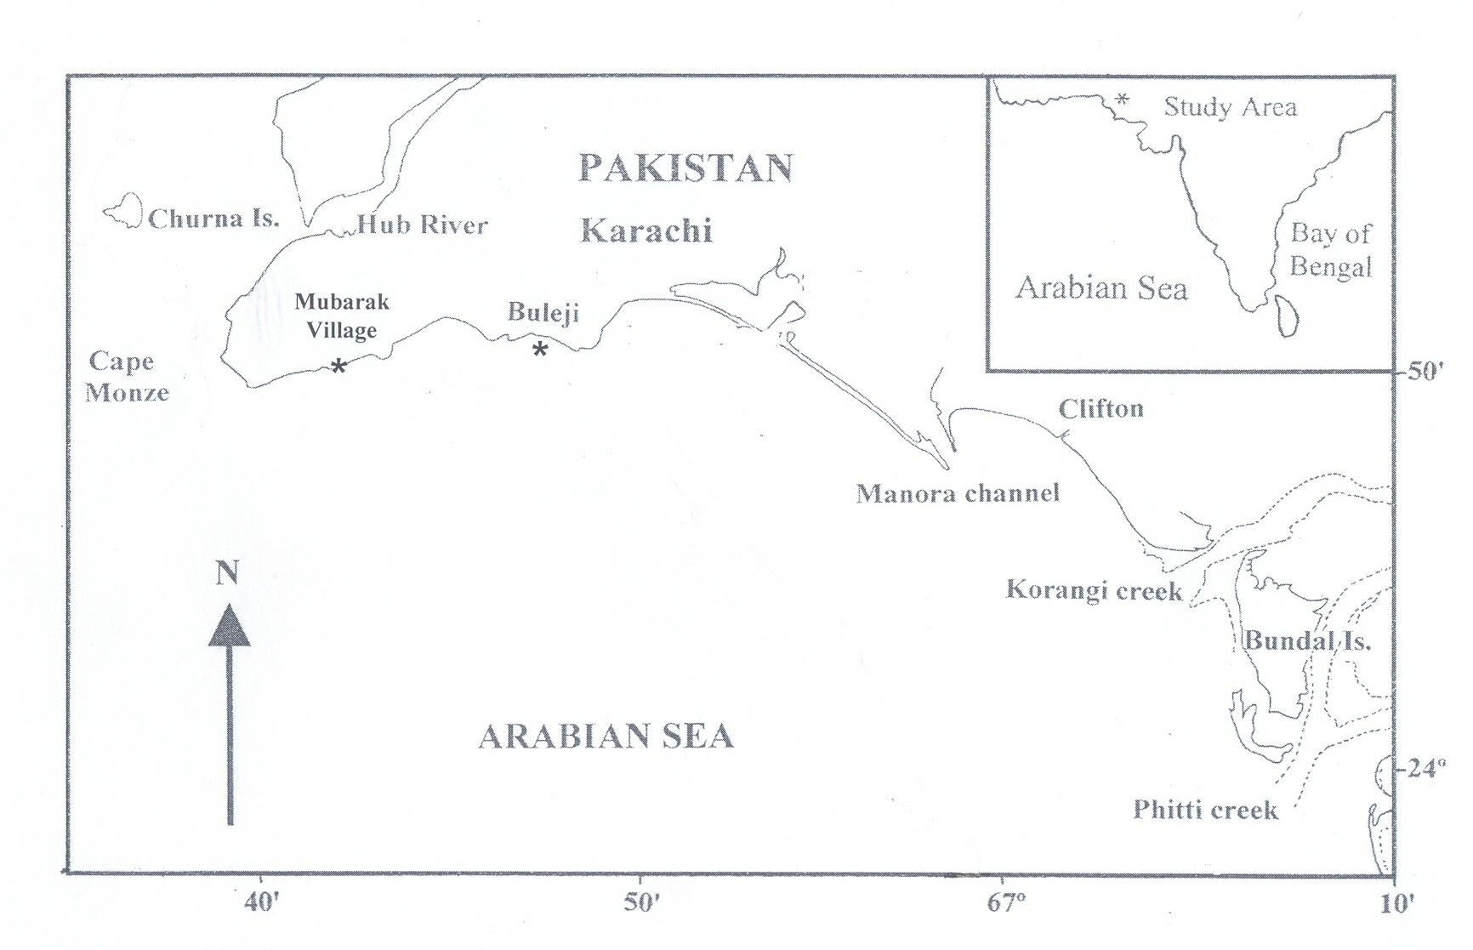
Sandspit
Hawkes Bay
*

Fig. 1. Map showing the location of the three sampling sites (Buleji, Sandspit, and Mubarak Village) along the coast of Karachi, from where samples of Siphonaria species were collected.

The specimens were identified following the literature of Bosch et al. (1995) and the maximum shell length of each specimen was measured with vernier calipers (± 0.1 mm).

Results
Systematics
Phylum: Mollusca
Class: Gastropoda
Subclass: Pulmonata
Order: Basommatophora
Superfamily: Siphonarioidea
Family: Siphonariidae
GENUS: SIPHONARIA

Siphonaria ashgar Biggs, 1958
(Fig. 2A, B)

Numbers of individual collected: 1288
Size: 3-22 mm
Locality: Buleji, Sandspit and Mubarak Village

Diagnosis
The shell is thick and conical; central apex smooth, the outer margin is nearly smooth with faintly marked siphonal groove. The shell is etched with variable numbers of radial ribs (usually 38-46), between each of which are thinner ribs. Interior of the shell is light or dark brown with white and off-white radial streaks at the margin. The species was found attached on rocks at 3 meters above the mean sea level.

Distribution
This species was first described by Biggs (1958) from Persian Gulf. It was also reported in the Gulf of Oman (Bosch et al., 1995) and Kuwait Bay (Abdul-Salam and Al-Khedery, 1992).

Siphonaria belcheri Hanley, 1858
(Fig. 2C, D)

Numbers of individual collected: 793
Size: 5-22 mm
Locality: Buleji, Sandspit and Mubarak Village

Diagnosis
The shell is thick and low conical, the outer margin is not very smooth and the siphonal groove projects prominently. The sculpture consists of variable numbers of strong radial ribs (usually 12-16) with narrower ribs between them. Two radial ribs are nearly fused at site of the siphonal groove. The shell is off-white with brown stripes; interior of shell has white rays with pale brown colour in between, muscle scar is light orangish. The species was found attached on the rocks at 1-2 meters above the mean sea level.

Distribution
The species was reported from Arabian Sea, Mediterranean (Turkey) and Mauritius (Trew, 1983; Bosch et al., 1995; Albayrak and Çağlar, 2006).
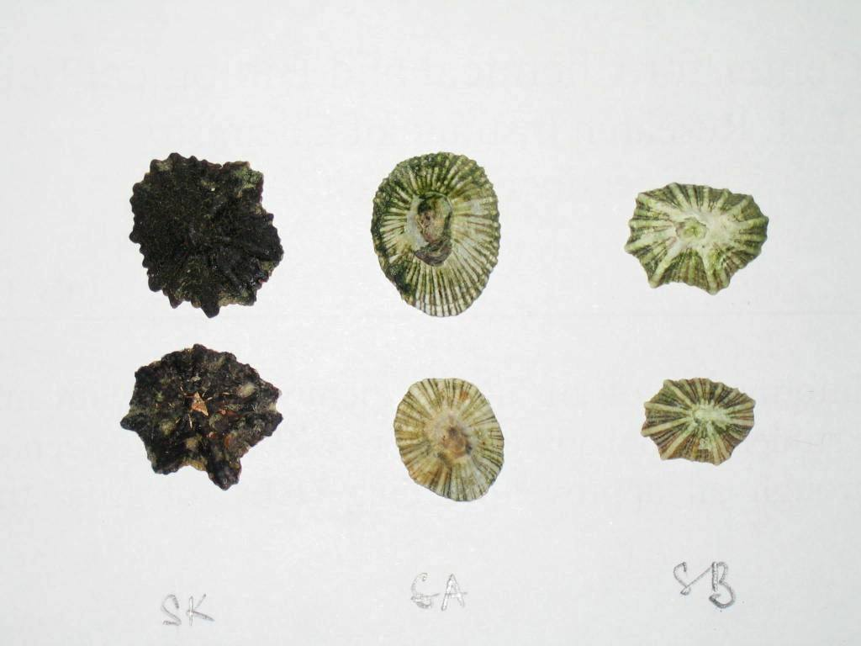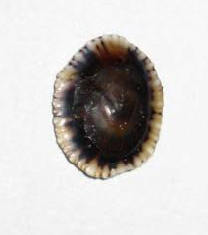
A
B
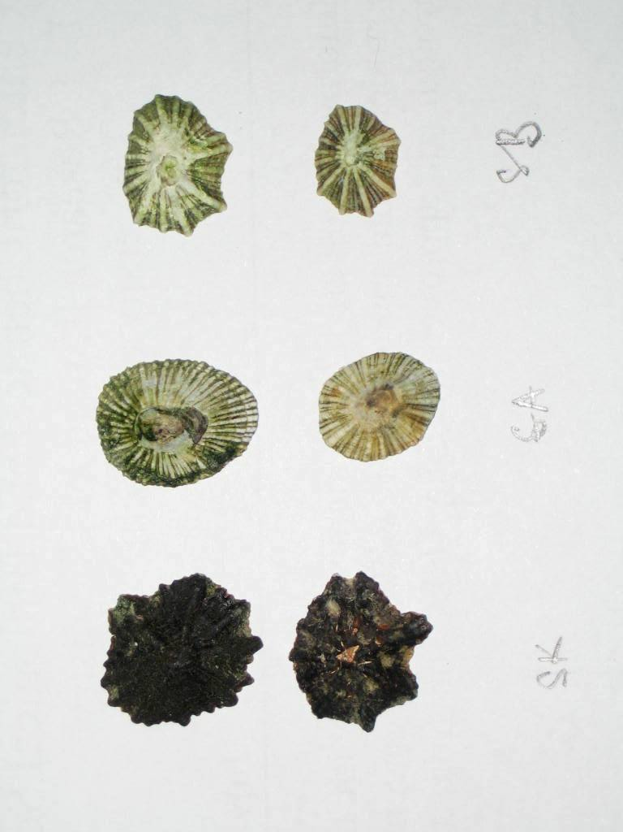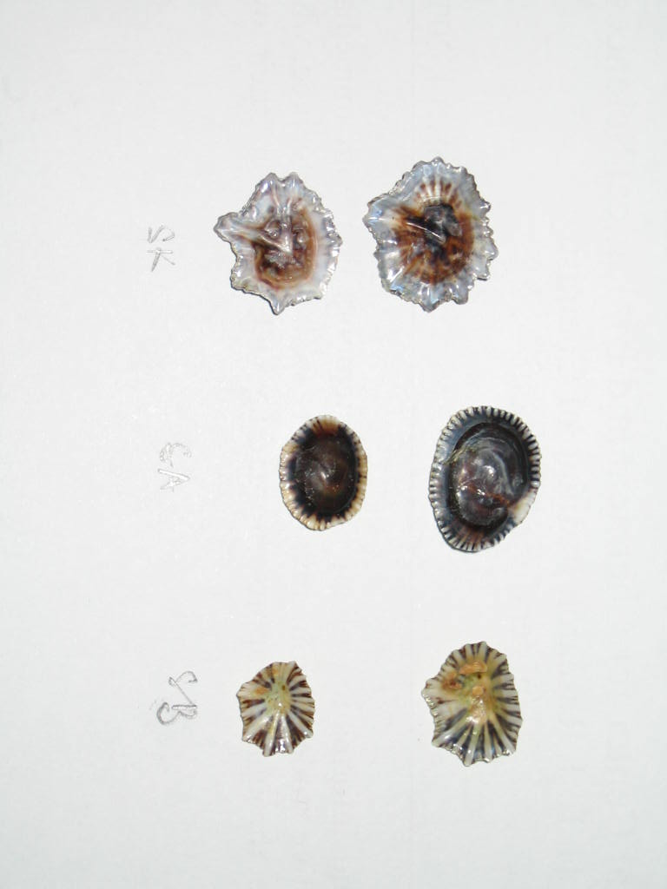
C
D
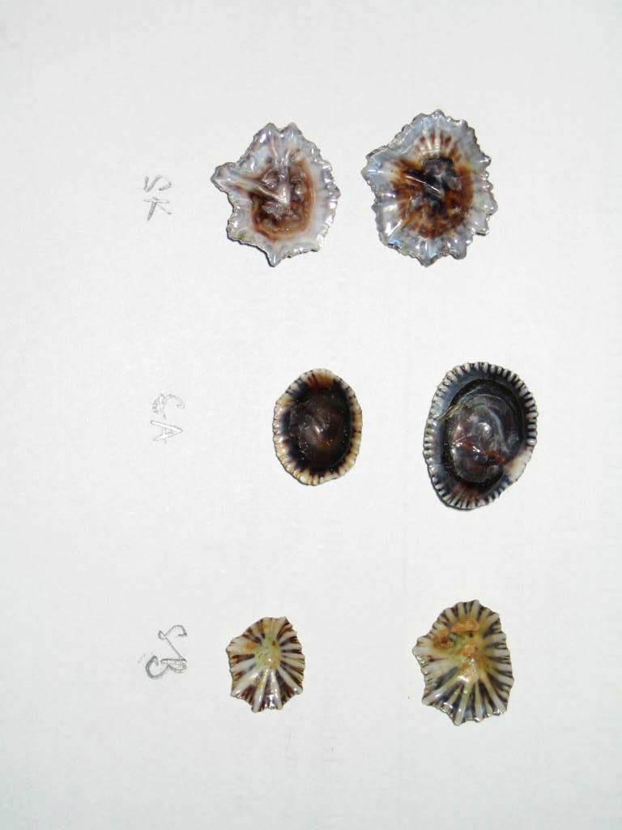
E
F

Fig. 2. Siphonaria species; dorsal (A) and ventral (B) views of Siphonaria ashgar; dorsal (C) and ventral views of S. belcheri (D); dorsal (E) and ventral (F) views S. kurracheensis:. Scale= 5 mm.

Siphonaria kurracheensis Reeve, 1856
(Fig. 2E, F)

Numbers of individual collected: 270
Size: 7-22 mm
Locality: Mubarak Village

Diagnosis
The shell is moderately thick and flattened, with variable number of strong radial ribs (usually 10-14) projecting from outer margin of shell, the siphonal groove prominent. Outer shell is brown with ribs darker brown; interior of shell is light brown with white or beige colour in the centre. This species was found attached to rocks at 0.5 meter above the mean sea level.

Distribution
A holotype of this species was collected from Karachi (Reeve, 1856). It was also reported from Mekran Coast (Pakistan) (Melvill and Standen, 1901). This species has a wide distribution in the Indo-West Pacific region and was reported in Western Australia, New Caledonia, India, Persian Gulf, Gulf of Oman, Philippines, Hong Kong, Samoan Islands and Hawaiian Islands (Trew, 1983; Bosch et al., 1995).

Discussion
The shells of Siphonaria are commonly called as false limpets because of their superficial resemblance to true limpets (Patelloidea) to whom they are distantly related. One of the authors of this MS has made frequent visits in last 35 years to the rocky coasts off Karachi and always found Siphonaria species in the area and thus this species cannot be considered as an invasive species. It is possible that the earlier studies conducted on the gastropod fauna (Khan and Dastagir, 1970; Ahmed et al., 1982; Barkati and Burney, 199l; Moazzam and Ahmed, 1994; Ahmed and Hameed, 1999; Nasreen et al., 2000) due to the small sizes of Siphonaria spp. either neglected it or incorrectly identified them as Patella or Cellana spp. as these two species are abundant on rocky coasts.

References
Abdulsalam, J. and Alkhedery, B., 1992. Hydrobiologia, 248: 161-165.
Ahmed, M., Rizvi, S. H. N. and Moazzam, M., 1982. Pakistan J. Zool., 14: 175-184.
Ahmed, M. and Hameed, S., 1999. Pakistan J. biol. Sci., 31: 81-91.
Albayrak, S. and Caglar, S., 2006. Aquat. Invas., 1: 292-294.
Barkati, S. and Burney, S.M.A., 1991. Nat. Sci. Res. Develop. Bd, Univ. Karachi. 90p.
Biggs, H. E. J., 1958. J. Conch. London, 24: 249.
Bosch, D. T., Dance, P., Moolenbeek, R. G. and Oliver, P.G., 1995. Seashells of eastern Arabia. Motivate Publishing, Dubai, UAE, pp. 296.
Hanley, S., 1858. Proc. zool. Soc. London, 26: 23-25.
Hodgson, A. N., 1999. Oceanogr. Mar. Biol. Ann. Rev., 37: 245-314.
Hubendick, B., 1946. Kungl. Sven. Vetenskapsakad. Handli. Tred. Ser., 23: 5-93.
Hubendick, B., 1947. Zool. Bidrag. Fran. Uppsala, 24: 1-216.
Khan, M. D. and Dastagir, S. H., 1971. Rec. zool. Surv. Pakistan, 2: 17-131.
Melvill, J.C. and Standen, R., 1901. Proc. zool. Soc. London, 2: 327-400.
Moazzam, M. and Ahmed, J., 1994. Proc. nat. Semi. Fish. Polic. Plan. Mar. Fish. Dept., Govt. Pakistan.
Nasreen, H., Ahmed, M. and Hameed, S., 2000. Pakistan J. Zool., 32: 343-350.
Quraishee, G. S., 1975. Int. Conf. Managm. Environ. Pakistan Acad. Sc., Islamabad, pp. 111-112.
Reeve, L., 1856. Conchologia Iconica. Reeve and Co, Kent.
Trew, A., 1983. Part 16, Siphonariacea. National Museum of Wales, Wales. U. K.

(Received 25 August 2010, revised 11 October 2011)

Pakistan J. Zool., vol. 43(3), pp. 604-606, 2011.

Juveniles of Genus Oligacanthorhynchus Travassos, 1915 (Acanthocephala: Oligacanthorhynchidae Southwell & Macfie, 1925) From Snakes in Karachi, Pakistan

Richard A. Heckmann,¹ Aly Khan,²* and Omer M. Amin³
¹Dept. of Integrative Biology, 401 W1DB, Brigham Young University, Provo, Utah-84602
²Crop Diseases Research Institute, PARC, University of Karachi, Karachi-75270
³Institute of Parasitic Disease, 11445 E, Via Linda, # 2-419, Scottsdale, Arizona 85259, U.S.A

Abstract:- This investigation was conduct to identify Acanthocephalan from snakes of Sindh. A total of six snakes (Naja naja) were examined and all were infected with Oligacanthorhynchus Travassos, 1915 juveniles. SEM revealed the shape of the hooks and nature of the integument.

Key words: Acanthocephala, juveniles, snakes, Oligacanthorhynchus, Sindh.

___________________________
* Corresponding author: aly.khan@hotmail.com
Acanthocephalans of genus Oligacanthorhynchus Travassos, 1915 are parasites of birds and mammals, juveniles commonly found encysted in reptiles (Schmidt, 1972). In a survey of acanthocephalan parasites from reptiles of Karachi, six snakes (Naja naja Linnaeus) were dissected during August 2009 to January 2010. All the six snakes were infected with juveniles of genus Oligacanthorhynchus Travassos, 1915, recovered from the body cavity.

Materials and methods
The snakes (Naja naja) were caught from Karachi University Campus, Sindh, Pakistan. The number of parasites per host ranged between 14 to 96 specimens per host. Twenty six acanthocephalan collected from the body cavity and intestine were fixed in F.A.A. solution under slight glass slide pressure, stained with Mayer’s carmalum, dehydrated in graded series of alcohol cleared in clove oil and xylol, and mounted permanently in Canada balsam. Standard methods were used to prepare each specimen for SEM which included critical point drying and attaching the specimen to stubs. Samples attached to stubs were examined with an Environmental SEM (XL330ESEMFEG) equipped with an EDXA or (Phoenix Energy Dispersive X-ray Analyzer). SEM micrographs at various magnifications were taken.

Results and discussion
The juveniles had inverted proboscis, body medium sized 2.3–2.8 mm (Figs. 1, 2), proboscis was more or less globular, the proboscis hooks stout in laeotropical spiral rows emerging from a elevated rim from proboscis surface as seen in scanning electron micrograph (Fig. 3), some hooks have collagenous fibres strands attached (Fig. 4). The hooks are used for host attachment (Figs. 5, 6, 7). Body integument not smooth but with micropores throughout the body which are used for absorbing food from the host (Fig. 8). Probably the snake acts as intermediate host.
In an earlier study juveniles of genus Oligacanthorhynchus Travassos, 1915 were recovered from the small intestine of Uromastix hardwicki Gray from Karachi, Pakistan (Khan et al., 2004). This is the first record of genus Oligacanthorhynchus in snake from Pakistan. So far only two species of the genus namely Oligacanthorhynchus cati (Gupta and Lata, 1968) Schmidt, 1972 and O. indicus Ranguraja and Das, 1981 have been reported from India.

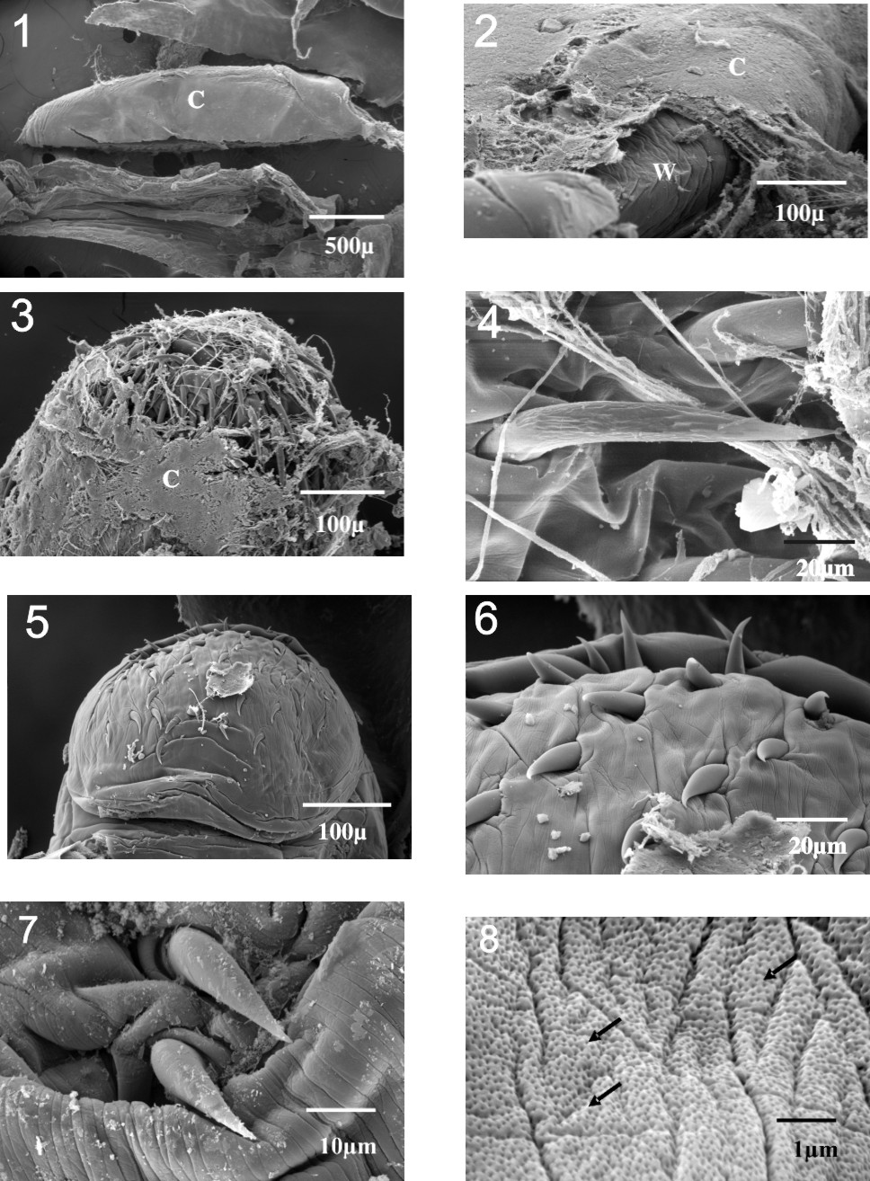

Figs. 1-8. 1, An encapsulated juvenile (Cystacanth) found in the host; 2, the worm (W) exposed after part of connective tissue capsule (C) has been removed; 3, as more of the connective tissue is removed the proboscis hooks become visible; 4, hook from the exposed proboscis with strands of collagenous fibres appearing next to the hooks; 5, the exposed proboscis acanthocephalan after the capsule is removed, note numerous hooks; 6, higher magnification of the hooks; 7, typical hooks for the proboscis, used for attachment; 8, The integument of the worm with numerous micropores (arrow), the micropores are used for absorbing food from the host.

References
Gupta, N.K. and Lata, V., 1968. Res. Bull. Punjab Univ. (Sci) 18: 253-268.
Khan, A., Khatoon, N. and Bilqees, F.M., 2004. Pakistan J. Zool., 36: 344.
Schmidt, G.D., 1972. J. Parasit., 58: 290-297.

(Received 9 July 2010, revised 28 October 2010

Pakistan J. Zool., vol. 43(3), pp. 606-608, 2011.

Preference of Substrate and Shelter Type by the Snapping Shrimp, Alpheus lobidens De Haan, 1849 (Crustacea: Caridea: Alpheidae)

Abdul-Reza Dabbagh* and Ehsan Kamrani
Department of Marine biology, Faculty of Basic Sciences, University of Hormozgan, PO Box, 3995, Bandar Abbas, Iran.

Abstract.- Alpheus lobidens tend to dwell under rocks along the coast of Bandar-e Lengeh. To test for preferences in habitat type, specimens were exposed to different types of substrates and shelters in the laboratory. Our findings indicated that shrimp significantly prefer opaque shelters on sand mixed with gravel. The preference for a secure and dark habitat probably helps the shrimp to avoid being eaten by predators.

Keywords: Ecology, habitat, alpheidae, Alpheus lobidens, Persian Gulf.

Substrate composition, texture, and the presence of shelter may strongly affect population and community structure of burrowing organisms, as well as their burrowing behaviour (Palomar et al., 2005; McLachlan, 1996). The intensity, duration and success of agonistic interactions are also affected by number of shelters available, as is the probability of survival (Martin and Moore, 2008). In the laboratory, many organisms exhibit preferences for certain types of subtrates and shelters [such as snapping shrimp (Rahman et al., 2004), crayfish (Martin and Moore 2008), spiny lobsters (Eggleston and Lipcius, 1992), hermit crabs (Rodrigues et al., 2000) and fish (Faria et al., 1998)].
___________________________
* Corresponding author: Rezadabbagh@yahoo.com
Materials and methods
Alpheus lobidens was collected from a rocky shore next to the Persian Gulf Molluscs Research Station (PGMRS) at Bandar-e Lengeh, Hormozgan province, Iran. In the collecting area, the snapping shrimps were always found under rocks with sand and gravel (Personal Observation).
The collected specimens were transported to the laboratory and left for 2 d before the experiments. Sediment was collected and then filtered using a hand sieve with a 2 mm mesh-size to separate gravel from sand. To test whether A. lobidens can discriminate between kinds of habitats, the following experiment was designed. Three aquaria with the same size were used (60 cm length, 30 cm width, and 40 cm height). The walls of each aquarium were covered with dark covers. Each aquarium was subdivided into four equal-sized sections characterized as follows: a) sand with transparent shelter (gravel grain size was bigger than 2 mm), b) sand with the opaque shelter, c) mixture of gravel and sand (about 50 % gravel), with transparent shelter, and d) mixture of gravel and sand (about 50 % gravel), with opaque shelter. The shelters to be competent to prefer, they were made of plastic tubes; some tubes were transparent types, while the rests were opaque ones.
We introduced one shrimp into each of the three experimental aquaria in the afternoon. Ten seven-day trials were run, which in total used 30 different animals (One individual per each aquarium). The locality of each of the shrimp was recorded each morning. The obtained data were analyzed with chi-square tests.

Results and discussion
Immediately after introduction to the aquaria, the shrimp looked for shelter. Overnight, the shrimp moved throughout the aquarium looking for a suitable shelter and substrate.
The positions of the shrimp indicated significant preferences among the four shelter types on all seven days (See Figs. 1 to 7; χ², df =3; Day 1 = 13.2, the two tailed P value = 0.0042; day 2= 12.933, the two tailed P value = 0.0048; day 3= 16.133, the two tailed P value = 0.001; day 4= 10. 267, the two-tailed P value = 0.0164; day 5= 4.667, the two-tailed P value = 0.1979 (N.S); day 6= 1.733,

1 |  | 2 |  | 3
4 |  | 5 |  | 6
 |  | Figs. 1-7. Number of shrimps that chose each of the four conditions during seven days of observation. Gravel (G); Sand (S); Opaque Shelter (OS); Transparent Shelter (TS); χ², for 1=13.2, p< 0.005); 2 = 12.933, P<0.005; 3 = 16.133, P<0.002; 4=10.267, P<0.02; 5=4.667, P>0.05; 6=1.733, P>0.005; 7=4.667, P>0.05
 | 7

the two tailed P value = 0.6295 (N.S.); day 7=4.667, the two tailed P value = 0.1979 (N.S.); p<0.02 only on days 1-4). Even though all days did not show significant differences, the pattern of the shrimp’s preference behaviour was similar on all seven days. On six of seven days an opaque shelter with sand and gravel was the most preferred location, and on six of seven days a transparent shelter with sand was the least preferred (or was tied for the least preferred) location. A transparent shelter with gravel and sand was preferred over an opaque shelter with sand on five of seven days, but the strength of this preference was never strong
The results of our laboratory experiment showed that A. lobidens prefers dark locations on substrates of gravel and sand. Darkness would be correlated with lack of visibility to potential predators. Gravel with sand may be easier to move than pure sand for this species when constructing a burrow or it may be correlated with preferred foods. The weakening of preferences over the course of the experiment might have been due to the shrimps’ becoming less selective in the absence of natural signals. Whatever the selective forces involved, these preferences would likely lead to the distribution patterns we observed in the natural habitat (under rocks in substrates of sand mixed with gravel).
Acknowledgments
Authors wish to thank Dr. Nancy Knowlton for comments on the methods. We would also thank Dr. Reza Naderloo for advice and comments on an earlier version of this manuscript and Dr. Patrica Bachwell for providing us with references.

References
Eggleston, D.B. and Lipcius, R.N., 1992. Ethology, 73: 992-1011.
Faria, C., Almada, V. and Carmo Nunes, M.D., 1998. J. Fish Biol., 53: 1263-1273.
Martin, A.L. and Moore, P.A., 2008. Ethology, 114: 351-360.
McLauchlan, A., 1996. Mar. Ecol. Prog. Ser., 131: 205-217.
Palomar, N.E., Juinio-Meñez, M.A. and Karplus, I., 2005. J. Ethol, 23: 173-180.
Rahman, N., Dunham, D.W. and Govind, C.K., 2004. Crustaceana., 77: 95-111.
Rodrigues, L.J., Dunham, D.W. and Coates, K.A., 2000. Crustaceana, 73: 737-750.

(Received 23 August 2010, revised 25 November 2010)

Pakistan J. Zool., vol. 43(3), pp. 608-611, 2011.

Detection of Rabies Virus From Equines Showing Nervous Signs

Muhammad Zubair Shabbir, ¹*, Masood Rabbani, ¹ Arfan Ahmad, Tahir Yaqub, ¹ Khushi Muhammad² and Zia ur Rehman³
¹University Diagnostic Laboratory, ²Department of Microbiology, and ³Department of Clinical Medicine and Surgery, University of Veterinary and Animal Sciences, Lahore, Pakistan

Abstract.- Serum and cerebro-spinal fluid (CSF) of equines showing nervous sign suspected of rabies in northern areas of Pakistan during the month of November-December 2006 were processed for antibody determination through ELISA which showed non protective titter (≤0.5 EU/ml). Histopathology revealed absence of Negri bodies in formalin fixed tissue of brain. The mouse inoculation test showed typical rabies sign as compared to control mice which did not show any such signs. Diagnosis
_________________________
* Corresponding author: vetvains@uvas.edu.pk
was further confirmed with immuno-flourescence technique and amplification of nucleoprotein gene of rabies virus by RT-PCR.

Key words: Equine rabies, immunoflourescence, RT-PCR

Rabies is one of the most dreadful zoonotic diseases of the world caused by Lyssaviruses (Delmas et al., 2008) of the family Rhabdoviridae. In Asia, rabies is one of the most important diseases that have major public health significance with an estimated 32000 deaths and 96.5% of economic burden in the developing world (Keane and Little, 1987) particularly Pakistan which have no specific strategies to control the rabies. Undoubtedly, rabies is the most neglected field in Pakistan and claims to have 2000 – 10,000 deaths annually (Ahmad, 2001).
Currently, there are seven genotypes identified but classical rabies is caused in the vast majority of cases by genotype 1 virus (Delmas et al., 2008). These viruses circulate in the terrestrial hosts like dogs (Canis familiaris), foxes (Vulpes vulpes), and jackals (Canis aureus) (Metlin et al., 2006) and these are in abundance in northern areas of Pakistan. Most of the time disease is transmitted through bites via infected saliva (Gerard et al., 2005).
In equines, rabies is clinically difficult to distinguish from other neurological disorders (Keane and Little, 1987) such as equine encephalomyelitis, toxoplasmosis and listeriosis. Thus, its confirmation in the laboratory is essential. The microscopic examinations for negri bodies (Acha and Szyfres, 1989), mouse inoculation test (MIT) (Mslin et al., 1996), fluorescent antibody test (FAT) (Meslin et al., 1996) and RT-PCR are the most usual recommended techniques for rabies diagnosis (Silva et al., 1974). Together, these methods can reliably identify rabies up to 98 per cent but require either fresh, frozen or glycerol preserved samples (Johnson et al., 1980). Though, some investigators have reported Immuno-fluorescence based antigen detection from formalin fixed tissues but these methods are not reproducible in the laboratory (Sylvia et al., 2001). However, RT-PCR can be used for confirmed presence of rabies virus in suspected samples even though it is decomposed or formalin fixed (Choi et al., 2004). The aim of this investigation was to confirm the etiological agent from nervous tissue suspected of rabies virus using conventional and molecular techniques.

Materials and methods
A nervous disease outbreak in equines of 1–5 years age and either sex was reported at a Stud Farm Batrasi, Abottabad, Khyber Pakhtun Khaa during the month of November-December 2006. About 400 animals, mules as well as horses of five different breeds like Suffolk, Percheron, Thoroughbred, Clevland and Arabian were present at this farm. The animals were showing nervous sign, abnormal vocalization, head tossing, drooling of saliva, retention of urine and dilation of pupil followed by death within one week. A total of 11 animals showing these signs were died. Serum, CSF and brain samples in duplicate, with and without 10 per cent formalin, from 11 dead horses, suspected of rabies were received at the University Diagnostic Lab. The serum and CSF samples, taken before death, were processed for determination of antibodies against rabies using SERELISA rabies Ab Mono Indirect Kit (Synbiotics, France) as per manufacturer’s instructions while brain samples were processed for histopathology, MIT, FAT and RT-PCR.
Brain tissue samples fixed in 10% formalin (5mm in thickness) were processed by routine methods for paraffin embedding. Sections stained with hematoxylin and eosin was examined for Negri bodies and other histopathological changes. The MIT was conducted according to Meslin et al. (1996). Briefly, the 10% brain tissue was homogenized in phosphate buffered saline (pH 7.2) containing penicillin, streptomycin (0.02mg/ml) and centrifuged at 900x g for five min. The supernatant was collected and 0.03ml of each sample was used to inoculate 21 day-old albino mice (weighing 19g average) by intra- cerebral route. PBS was used for inoculation as negative control. The inoculated animals were observed daily up to 30days.
Immunofluorescence was carried out according to Meslin et al. (1996). Briefly, the acetone fixed imprints of the brain tissue were incubated with polyclonal anti-rabies fluorescein-labelled immunoglobulin (VMRD, Inc. USA). Rabisin and healthy equine saliva were used as positive and negative controls. The imprints were examined under a fluorescent microscope (Olympus, Japan).
The total RNA was extracted from brain samples using “One Step RNA Reagent” (Bio- Basic Inc., Canada) according to the manufacturer's instructions. Following cDNA synthesis using RevertAid first Strand Synthesis Kit (Fermentas, EU), the portion of nucleoprotein coding genome region of rabies RNA was amplified using forward primer (5’TTGT(AG)GA(TC)CAATATGAGTACAA3’) and reverse primer (5'CCGGCTCAAACATTCTTCTTA3') described by Davis (1998) with minor modification. Rabisin vaccine and healthy equine saliva were used as positive and negative controls respectively, during all procedures. The resulting amplicons (762 bp) were resolved by electrophoresis on 2.0% agarose gel, stained with ethidium bromide (0.2µg/ml), visualized and photographed by using a gel doc system (Biorad, Italy.)

Results and discussion
Serum and CSF samples showed non protective titre (0.2 - 0.5 EU/ml) that may be due to early stage or acute infection as intracellular axoplasmic transport prevents virus contact with cells of the immune system, although the virus is highly immunogenic (Quinn et al., 2002). The histopathological examination revealed absence of negri bodies in formalin fixed brain tissue samples. These findings are in line with the observations of Dupont and Earle (1965) and Mrak (2003). According to them negri bodies are inconstantly present and may not be detectable in 20-50% of cases of rabies encephalitis. It is not surprising as intracytoplasmic inclusions bodies are not a sensitive indicator of rabies virus infection, as noted by prior investigators (Depowski et al., 2002). Some authors have mentioned that negri bodies are not formed in equine nervous tissue (Silva et al., 1974).
The mice injected with infected brain suspension showed typical rabies signs
like agitation, restlessness, aerophobia, paralysis and
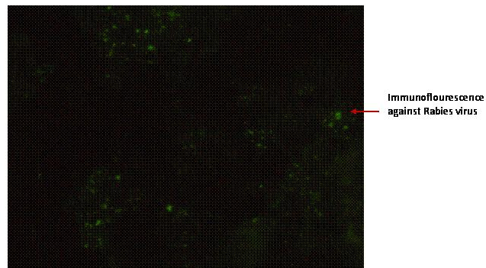

Fig. 1. Immunoflourescence of rabies from brain tissues with polyclonal FITC antibodies.

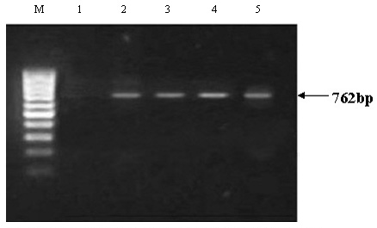

Fig. 2. Results of RT-0PCR obtained with Rabisin and brain samples from equines. Lane M, molecular size marker GeneRuler100bp DNA; Lane 1, negative control with normal saline; Lane 2, positive control with Rabisin vaccine; Lanes 3, 4, 5, samples found positive for rabies.

death, 22 days post inoculation. These finding showed deviation from the previous observation that states appearance of signs within 10 days (Elenice et al., 2005). Nevertheless, Zelia et al. (2000) have shown that antigen from equine nervous tissue have longer incubation period that can vary from 8 to 23 days. The equine brain samples and injected mouse brain tissues were analyzed by FAT using fluorescein isothiocyanate labelled conjugate. Prominent focal area of fluorescence was observed under the microscope in all samples from mice brain and positive control which were absent in the negative control samples (Fig 1). This corresponds to previous observations that revealed this method highly sensitive and specific and easy to perform and, thus, making it a standard diagnostic procedure for rabies diagnosis with 99.8% accuracy (Sylvia et al., 2001). Only one sample showed negative fluorescence from equine nervous tissue that may be due to autolysis or invariable distribution of rabies antigen in brain tissue (Sylvia et al., 2001). Several workers have reported, previously, problem with FAT when using autolysed or formalin fixed tissue specimen (Sacramento et al., 1991). The RT-PCR products were resolved by electrophoresis (Fig. 2). After electrophoresis, a specific 762bp amplicons was observed in all samples analyzed which were comparable to the positive control showing a 100% agreement with the MIT and FAT. The RT-PCR has proved to be rapid, highly sensitive and specific alternative diagnostic tool particularly in cases where the nature of sample is formalin fixed or decomposed (Sacramento et al., 1991). The selection of specific primers for the nucleoprotein region of rabies virus and rabies-related viruses increases the possibility of success to detect rabies infection (Heaton et al., 1997). So a rapid and more sensitive test like RT-PCR of rabies can be used as a routine diagnostic procedure (Botvinkin et al., 2003) in the laboratory. The present study emphasizes the importance of molecular methodologies used for identification and characterization of rabies virus.

References
Acha, P.N. and Szyfres, B., 1989. In: Zoonosis e enfermedades transmisibles comunes al hombre ya los animales. 2. ed. Washington, p.502-526.
Ahmad, K., 2001. Lancet, 358 (9275): 46.
Botvinkin, A.D., Poleschuk, E.M. and Kuzmin, I. V., 2003. Emerg. Infect. Dis., 9: 1623-1625.
Choi, C., Ha, S.K. and Chae, C., 2004. J. Virol. Methods, 115: 67–71.
Davis, S.A.N., 1998. J. Virol. Methods, 75:1-8.
Delmas, O., Holmes, E.C., Talbi, C., Larrous, F., Dacheux, L., Bouchier, C. and Bouhry, H., 2008. Plos One, 3: 2057-2063.
Depowski, P., Trimarchi, C. and Qian., 2002. Arch. Pathol. Lab. Med., 125: 491-492.
Dupont, J.R. and Earle, K.M., 1965. Neurology, 15: 1023-1034.
Elenice, M.S.C., Maria, C.C.S.H.L., Alessandra, F.C.N., Miriam, M.S. and Luis, F.V.A.M., 2005. Saude Publicat., 39-44.
Gerard, J.N., Dulcelena, L.D., Juan, G.C.V. and Yilan, Z., 2005. Mod. Pathol., 18: 62-67.
Heaton, P.R., Johnstone, P. and Mcelhinney, L. M., 1997. J. clin. MicrobioI., 35: 2762-2766.
Johnson, K.P., Peggy, T., Swoveland, M.S., Richard, W. and Emmons, M. D., 1980. J. Am. med. Assoc., 244: 41-43.
Keane, D.P. and Little, B.L., 1987. Can. Vet. J., 28: 497-504.
Meslin, F.X., Kaplan, M.M. and Koprowski, H., 1996. Laboratory techniques in rabies. 4th ed. WHO., Geneva: pp. 476.
Metlin, A.E., Holopainen, R., Tuura, S., Ek-Kommonen, C. and Huovilainen, A., 2006. J. Equine Vet. Sci., 26: 584-587.
Mrak, R.E. and Young, L., 2003. Human Pathol., 24: l09-110.
Quinn, P.J., Markey, B.K., Carter, M.E., Donnelly, W.J.C. and Leonard, F.C., 2002. In: Veterinary microbiology and microbial disease. 1st ed. Blackwell Science, USA, pp. 390-395.
Sacramento, D., Bourhy, H. and Tordo, N., 1991. Mol. Cell. Probes, 5: 229-240.
Silva, R.A., Silva, N.M. and Menezes, P.R.V., 1974. Pesq. Agrop. Bras., Sér. Vet., 9: 29-31.
Sylvia, G.W., Fekadu, M., Shaddok, J.H., Neizgoda, M., Warner, C. K. and Messenger, L.S., 2001. J. Virol. Methods, 95: 145-151.
Zélia, M.P.P., Elenice, M.S.C., Débora, R.V., Sacramento, M., Conceição, A.M.S., Luzia, Q.S., Pedro, L.G., Suzana, S. K. and Ivanete, K., 2000. Braz. J. Microbiol., 31: 78-84

(Received 23 June 2009, revised 24 March 2010)

Pakistan J. Zool., vol. 43 (3), pp. 611-614, 2011.

Improvement in Methionine Production by Local Bacterial Isolates

Nazish Mazhar Ali,¹ Farah Rauf Shakoori¹* and A.R. Shakoori²
¹Department of Zoology, GC, University Lahore
²School of Biological Sciences, University of the Punjab, Lahore

Abstract.- In the present study methionine producing bacteria from soil, water, milk, honey and sewage were isolated with an aim of their commercial exploitation. A total of 510 bacteria were isolated, of which 51.3% produced some amino acids viz. cysteine, methionine, lysine, glutamic acid and valine. The amino acid producing capability of the bacteria was improved using different types of fermentation media. 10g/l methionine was produced in FM6 (glucose 40g, KH₂PO₄, 0.5g, MgSO₄.7H₂O 0.3g and yeast extract 1.0g). This medium was found cost effective and has potential for further commercial exploitation.

Key words: Amino acid producing bacteria, microbial production of methionine, commercial production of methionine.

Amino Acids which are considered as the building blocks are not only involved in building cells and repairing tissues, but also form antibodies to combat invading foreign bodies like bacteria and viruses. Amino acids are involved in formation of proteins or other biomolecules, also are oxidized to ammonia and CO₂ and act as source of energy. Amino acids arginine, isoleucine, leucine, methionine, phenylalanine, threonine, lysine, tryptophan, histidine and valine are included in essential amino acids (Abe and Takayma, 1972). Amino acids overproduction at commercial level by bacteria is achieved by fermentation. Different wild and mutant strains of bacteria isolated from different natural sources are used in microbial fermentation of amino acids. Some wild strains of Corynebacterium glutamicum and Bacillus sp. are used for overproduction of different amino acids particularly lysine (Auger et al., 2002). In Pakistan, microbial production of amino acids has not been much exploited. Pakistan imports amino acids and there is need to explore the ways to utilize natural resources available locally to produce these amino acids on commercial scale. Several species of Streptomyces have been studied for methionine and other amino acid production. In the present work, the aim was to isolate methionine producing bacterial strains which can produce this amino acid on commercial scale. Nine bacterial strains (MM1-9) were isolated during this study which could grow in different fermentation media for commercial production of methionine. MM9 produced 10g/litre methionine in fermentation medium FM6. This bacterial strain and fermentation medium (FM6) can be used at commercial level for production of methionine.

Media and methods
Bacteria were isolated from different natural sources which included water, soil, milk, honey and sewage. For isolation of bacterial CFUs (colony forming units) from samples, nutrient agar and LB agar (Merck) were used. The composition of media used for isolation of amino acid producing bacterial strains is shown in Table I. A number of fermentation media were used for enhancing the production production of amino acids (Table II). These fermentation media which had molasses, corn steep liquor, urea and glucose were prepared and sterilized at 121ºC and 15lb pressure for 15-20 min (Benson, 2002). The initial pH of most of the fermentation media was kept neutral, while others were slightly acidic in order to observe the tendency to bacterial strains to produce amino acids in media of different pH.

Table I.- Composition of some of the basic media used for screening of amino acid producing bacterial strains.

Ingredient  (g/l) | Basic media
Ingredient  (g/l) | BM1 | BM2 | BM3 | BM4
Glucose | 10 | 01 | 20 | -
Peptone | - | 10 | - | 01
Beef extract | 01 | 02 | - | -
Yeast extract | - | - | 05 | 02
NaCl | - | - | - | 2.5
CaCO₃ | - | - | 10 | -

Table II.- Composition of some of the fermentation media for over production of methionine. FM6 supported production of 10g of methionine per litre of medium by isolate MM9.

Sr.No. | Ingredient | FM5 | FM6 | FM7 | FM8
1 | Glucose | 27g | 40g | 30g | 5.0g
2 | Urea | - | - | - | 8.0g
3 | K₂SO₄ | 20g | - | - | -
4 | KH₂PO₄ | - | 0.5g | 2.0g | 0.5g
5 | MgSO₄.7H₂O | 5.0g | 0.3g | - | 0.2g
6 | MnSO₄.H₂O | 0.4g | - | - | -
7 | (NH₄)₂HPO₄ | 20g | - | - | -
8 | NH₄H₂PO₄ | 20g | - | - | -
9 | FeSo₄.7H₂O | 0.2g | - | - | -
10 | Peptone | - | - | - | 2.0g
11 | Meat extract | - | - | - | 2.0g
12 | *CaCo₃ | - | - | 20g | -
13 | (NH₄)₂SO₄.7H₂O | - | - | 10g | -
14 | Phenol red | - | - | - | 0.015g
15 | Yeast extract |  | 1.0g | - | -
16 | MgCl₂.4H₂O | - | - | 10mg | -
17 | FeSO₄.4H₂O |  |  | 10mg | -
18 | Water | 1000ml | 1000ml | 1000ml | 1000ml
 | pH | 7.0 | 7.0 | 7.2 | 7.0
*CaCO₃ was added after sterilization of medium
Fermentation of amino acids
The screened bacterial strains were inoculated in 100ml of each fermentation medium in 250ml conical flasks. The flasks were incubated at 37±7ºC in shaker at 125 rpm for maximum 96 hours. After every 24 hours the 5ml sample was taken and cells were harvested. The harvest pH of each sample was recorded every time (Cheesebrough, 1993).

Analysis of amino acids
Five ml of fermented broth was taken out every 24 h centrifuged at 4000-5000rpm (2500xg) for 10min and supernatant used for analysis of amino acids. The supernatant was membrane filtered (0.45µm pore size) to make it cell free. The pellet was dried on filter paper at 70ºC for 48 h and weighed to determine cell mass (Hassan et al., 2003). The amino acids were analysed both qualitatively and quantitatively. Paper chromatography was used for qualitative analysis of amino acids. Whereas acidic ninhydrin method (colorimetric method) was used (Chinard, 1952) for quantitative analysis. To 50µl of culture supernatant 550µl of ninhydrin reagent was added in 5ml screw capped pyrex tubes. Known concentrations of standard solutions of amino acids were prepared in the same way. The tubes were heated for one hour in 100ºC water bath. After that tubes were cooled at room temperature and 1600µl of glacial acetic acid was added in these tubes. Optical density was recorded at 480 nm for methionine and quantity estimated using a standard curve prepared by taking known concentrations of methionine. The amino acid producing isolates were identified and characterized using different morphological and biochemical tests and determining nucleotide sequence of 16S rDNA.

Results and discussion
Out of a total of 510 isolates from different sources (Table III) 262 strains produced different amino acids. Of these only 9 strains, MM1-9 (Table V) produced methionine in significant quantities. The overall percentage of producers was 51.37% and that of best producers was 1.76% (Tables III, IV). One bacterial strain was selected which was unable to produce amino acids and it was named
as MM-control. Bacterial strain MM9 was isolated
Table III.- Amino acids producing and non-amino acids producing bacterial strains isolated from different sources.

Source | Total  no. of bacterial  isolates | Producers | Non-  producers | Best  producers
Water | 100 | 25 | 75 | -
Soil | 250 | 189 | 61 | 05
Milk | 50 | 05 | 45 | -
Honey | 60 | 23 | 37 | 02
Sewage | 50 | 20 | 30 | 02
Total | 510 | 262 | 248 | 09

Table IV.- Amino acids producing bacterial strains isolated from different sources during primary screening.

Source | Amino acids produced (per litre)
Source | 10-500  µg | 501-  1000  µg | 1.1-  50  mg | 50.1-  100  mg | 100.1-  999  mg | 1g or  above
Water | 25 | - | - | - | - | -
Soil | 52 | 40 | 26 | 37 | 19 | 05
Milk | 05 | - | - | - | - | -
Honey | 30 | 15 | 05 | 05 | 03 | 02
Sewage | 28 | 10 | 02 | 04 | 04 | 02
Table V.- The amount of methionine produced by different isolates after 96 hours of fermentation in different fermentation media.

Strain | Media | Methionine (g/l) | Harvest pH
MM1 | FM8 | 5.8 | 6.0
MM2 | FM16 | 7.8 | 6.5
MM3 | FM6 | 9.84 | 6.7
MM4 | FM6 | 9.96 | 5.89
MM5 | FM18 | 7.96 | 6.8
MM6 | FM6 | 9.5 | 6.5
MM7 | FM5 | 9.52 | 6.9
MM8 | FM6 | 9.98 | 6.9
MM9 | FM6 | 10.0 | 7.0

from honey sample and was identified as Bacillus sp. Using different fermentation media, this strain produced cysteine, methionine, lysine, glutamic acid and valine. This isolate however, showed significant production of methionine among the nine strains (Fig. 1) and showed optimum growth at pH 6 (Fig. 2) and 37°C (Fig. 3). L-methionine is one of
Fig. 1. Amount of methionine produced by MM9.

Fig. 2. Growth of methionine producing bacterial strain MM9 at different pH.

the most important amino acids for its applications for industry, pharmaceuticals, as feed additives as well as its role as methylating agent. Methionine has so far been produced mainly by resolution of recemic DL-methionine or it is being produded by extracting it from hydrolysis of proteins. The microbial production of methionine on the other hand has not been successful so far. Different strains

Fig. 3. Growth of methionine producing bacterial strain MM9 at different temperatures.

of E.coli and Bacillus sp. have been used for production of this amino acids but none of these have been commercially exploited so far.

References
Abe, S. and Takayma, K., 1972. Amino acids producing micro-organisms, variety and classification. The microbial production of amino acids. Kodanash, Tokyo. pp. 3-38.
Auger, S., Yuen, W.H., Danchin, A. and Martin-Verstraete, I., 2002. Microbiology, 148: 507–518.
Benson, H.J., 2002. Microbiological applications. 8th ed. Mc-Graw Hill, New York.
Cheesebrough, M., 1993. Medical microbiology: Manual for tropical countries, vol.II. Microbiology ELBs, University Press, Cambridge.
Chinard, F.P., 1952. J. biol. Chem. 1990- 91.
Hassan, B., Asghar, M., Nadeem, S. and Zubair, H., 2003. J. Biotechnol., 1: 18-29.
Khan, S.H., Rasool, G. and Nadeem, S., 2006. Pak. J. agric. Sci., 43(3-4).
Theodora, T. and Bustard, T., 2005. Proc. Biochem., 40: 499-508
Yangjian, L., Yingzi, Z., Jiang, W. and Yu, W., 2002. Acta microbiol. Sin., 42: 395-399.

(Received 3 June 2010, revised 12 December 2010)

SPEC 2: Species whose world populations are concentrated in Europe (i.e., over 50% of the total population or range occurs in Europe) and which have an unfavorable conservation status. * SPEC 3: Speciesl whose world populations are not concentrated in Europe, but which have an unfavorable status in Europe.

